**Implement AWS Monitoring and Alerts**

Sample Input:

You have multiple AWS resources, including EC2 instances, RDS databases, and Lambda

functions.

AWS CloudWatch for monitoring.

An email or Slack channel for receiving alerts.

Task:

Implement monitoring and set up alerts for key AWS resources to ensure proactive detection of

issues.

**Sample Output:**

**Sample Output 1: Configuration of AWS CloudWatch alarms that monitor critical metrics (e.g.,**

**CPU utilization, memory usage) for each resource**

* 1.Login to AWS Console: Log in to your AWS Management Console.
* 2.Access CloudWatch: Go to the AWS CloudWatch service.
* 3.Create Alarms:
  + In the CloudWatch console, navigate to the "Alarms" section.
  + Click the "Create Alarm" button.
* 4.Select Metric:
  + Choose the resource you want to monitor (e.g., an EC2 instance, RDS database, or Lambda function).
  + Select the relevant metric, such as CPU utilization or memory usage.
* 5.Define Conditions:
  + Set the threshold for the alarm. For example, if you want to be alerted when CPU utilization exceeds 80%, set that as the threshold.
  + Configure the period over which CloudWatch should evaluate the metric (e.g., 5 minutes, 15 minutes).
* 6.Actions:
  + Under the "Actions" section, choose "Add notification" to define the action when the alarm is triggered.
* 7.Create SNS Topic:
  + If you haven't already, create an SNS topic that will be used to send alerts to email or Slack. In the SNS service, create a new topic.
* 8.Specify SNS Topic:
  + In the alarm configuration, specify the SNS topic you just created as the notification target.
* 9.Configure Actions:
  + Define the actions you want to take when the alarm state is triggered. You can choose to send a message to an email address, a Slack channel, or any other SNS-supported notification method.
* 10.Add Name and Description:
  + Give your alarm a meaningful name and description for easy identification.
* 11.Create Alarm:
  + Review the configuration and click "Create alarm" to activate the alarm.

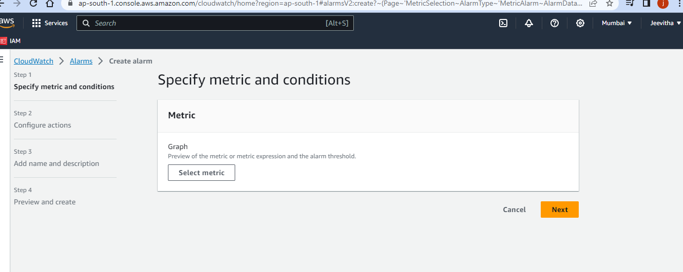

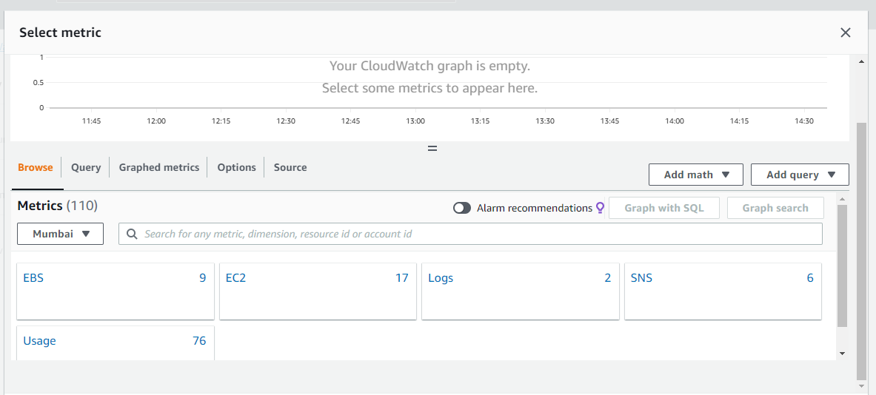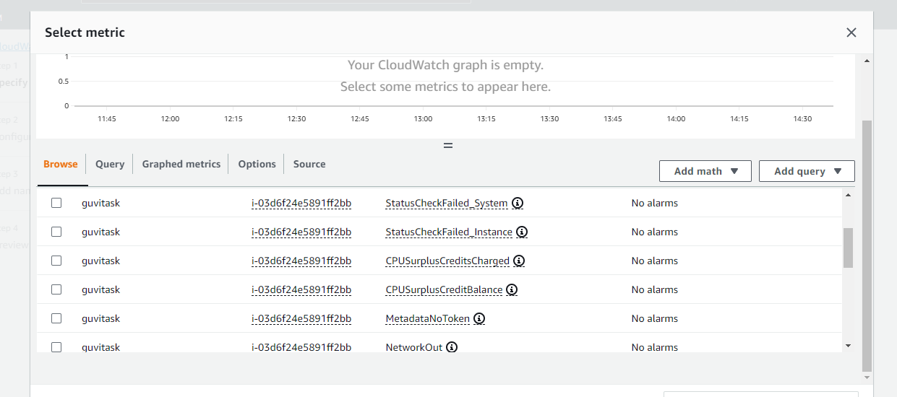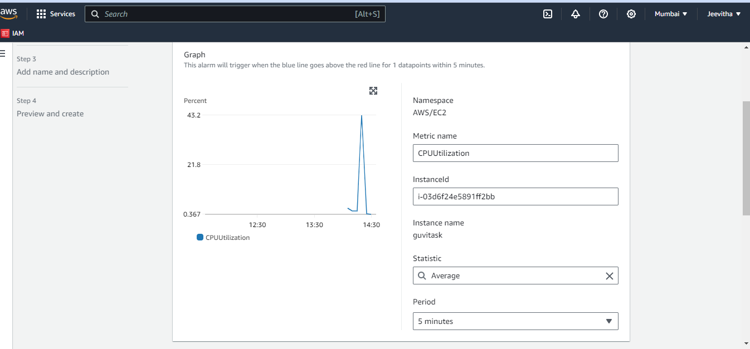

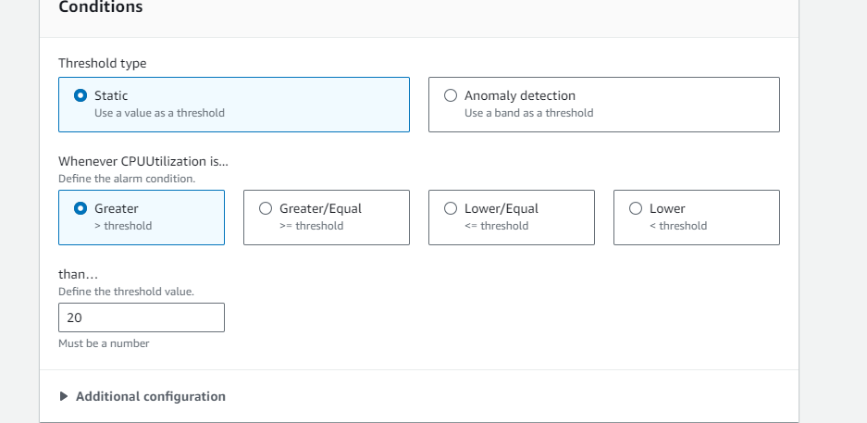

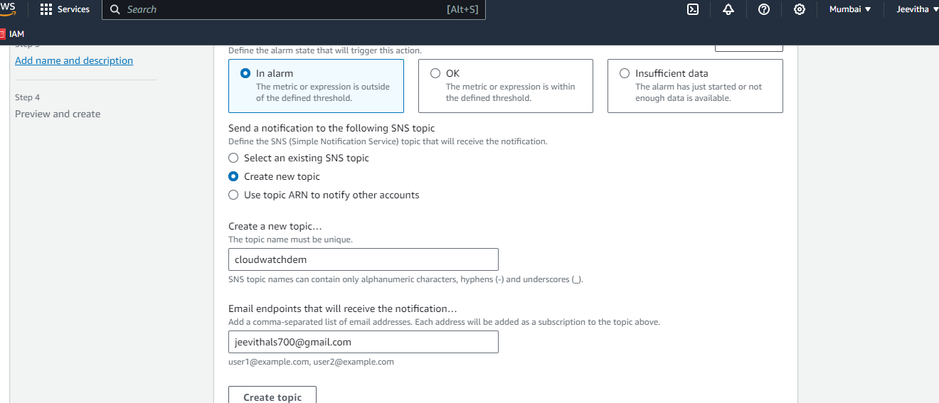

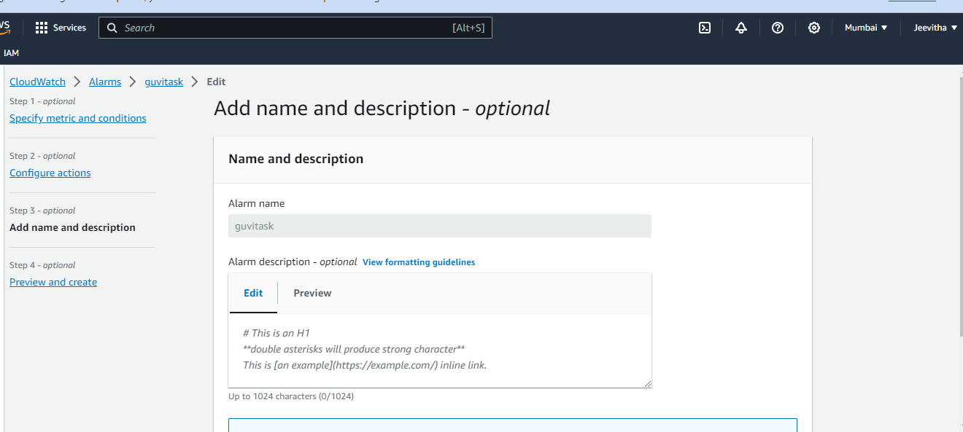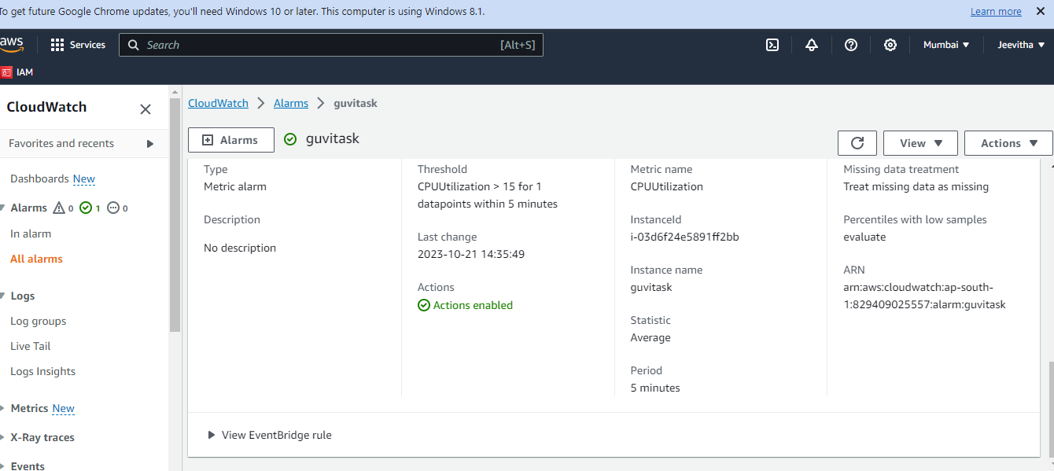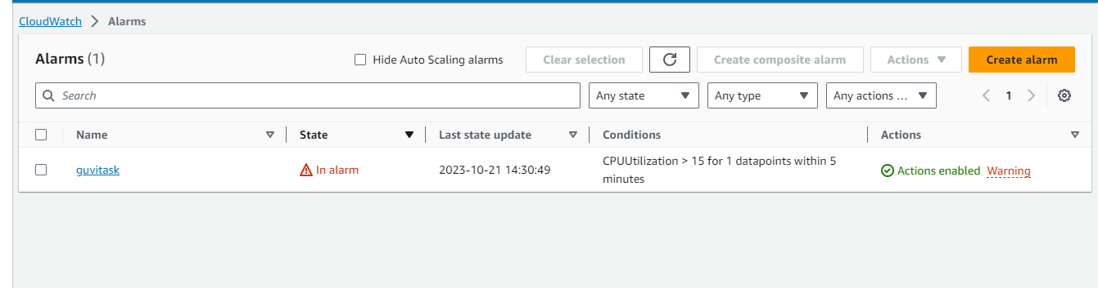

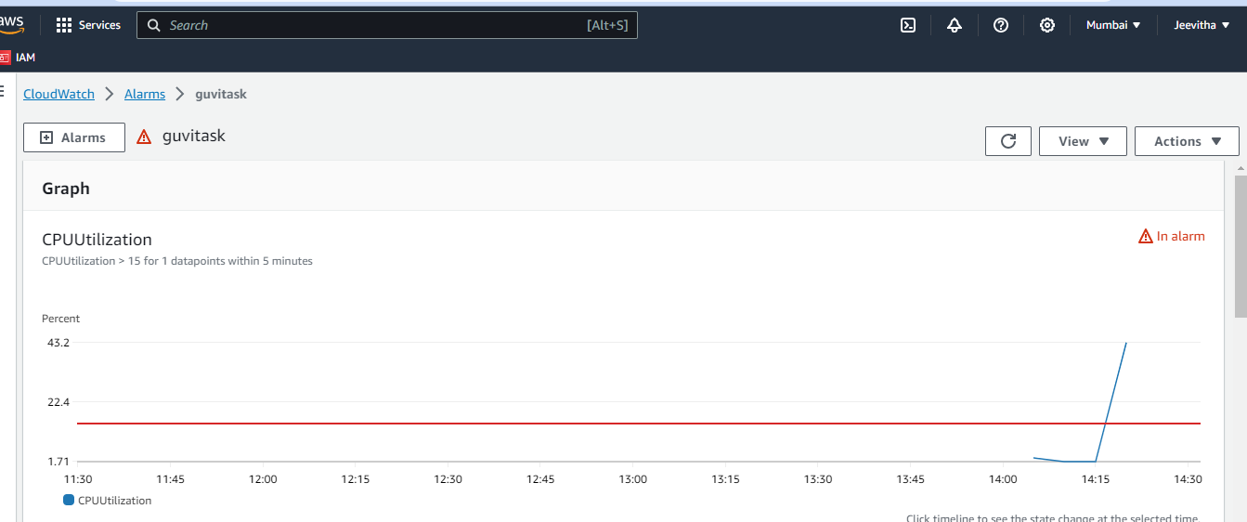

Sample Output 2: Integration of AWS SNS (Simple Notification Service) for sending alerts to

specific email addresses or Slack channels when alarms are triggered.

* 1.Create SNS Topic:
  + In the AWS SNS service, create a topic if you haven't already.
* 2.Subscription:
  + Add email addresses or Slack channel endpoints as subscriptions to the SNS topic. This allows these endpoints to receive notifications.
* 3.Notification Endpoint Verification:
  + Verify the subscriptions for email addresses by clicking on the confirmation link sent to the email. For Slack, you can follow the setup instructions provided in the SNS console.

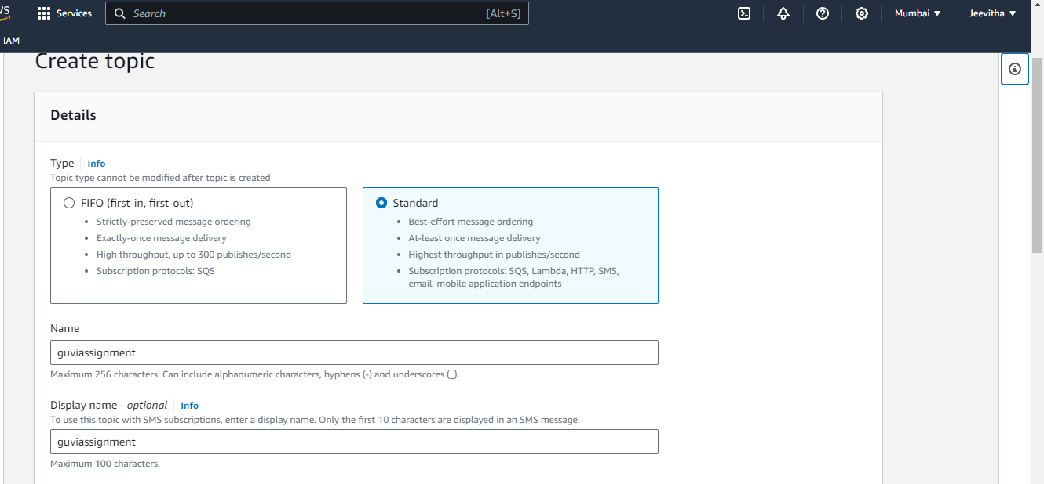

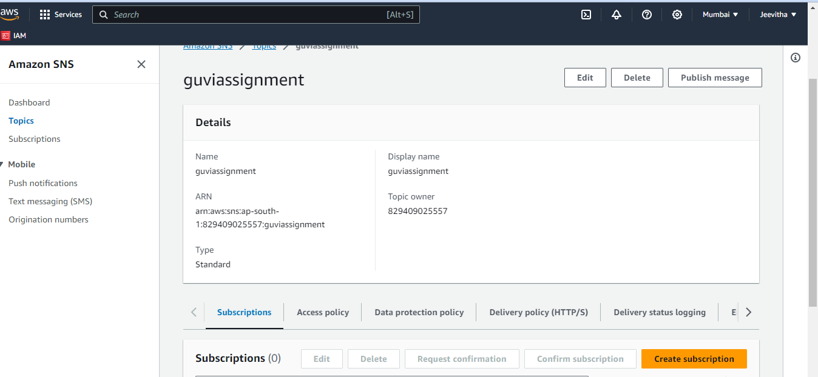

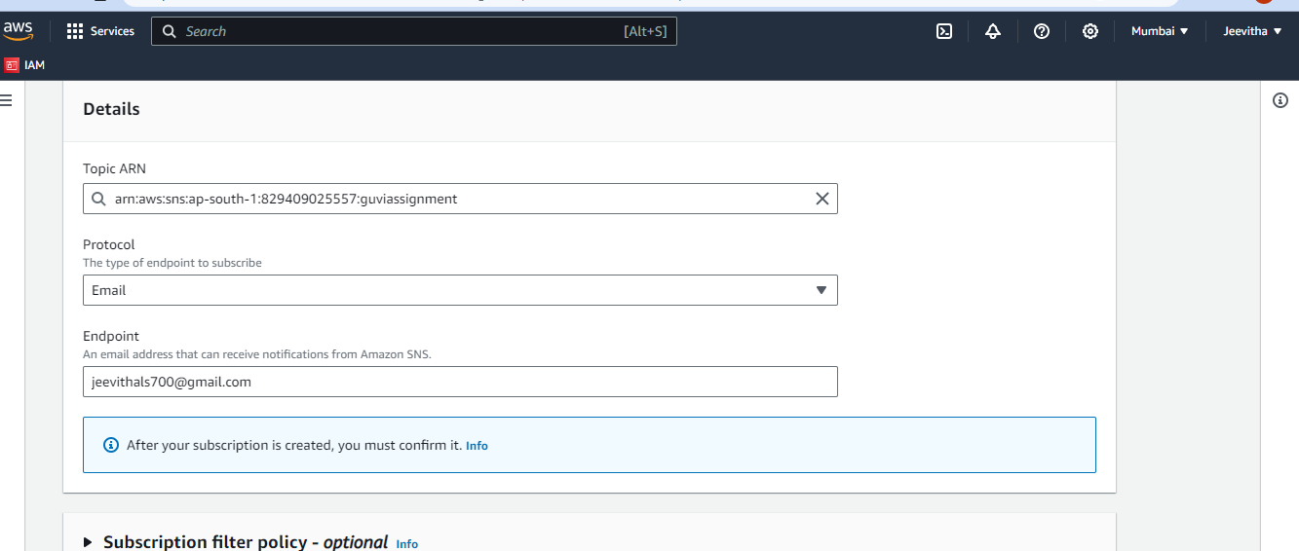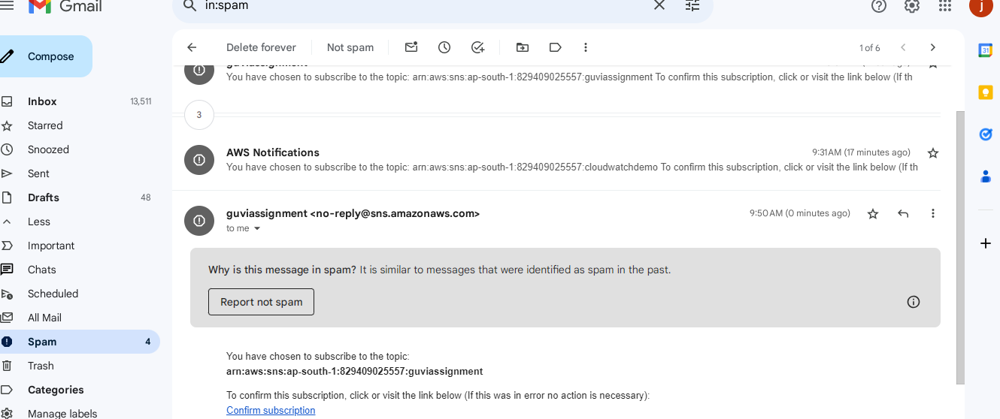

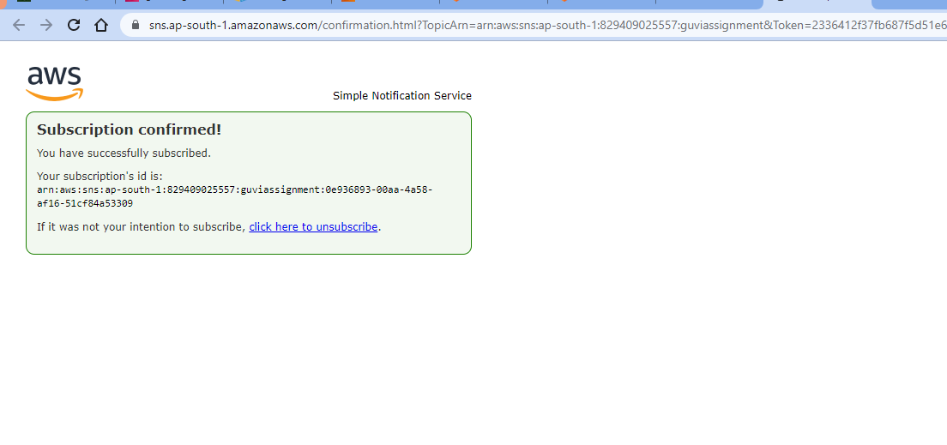

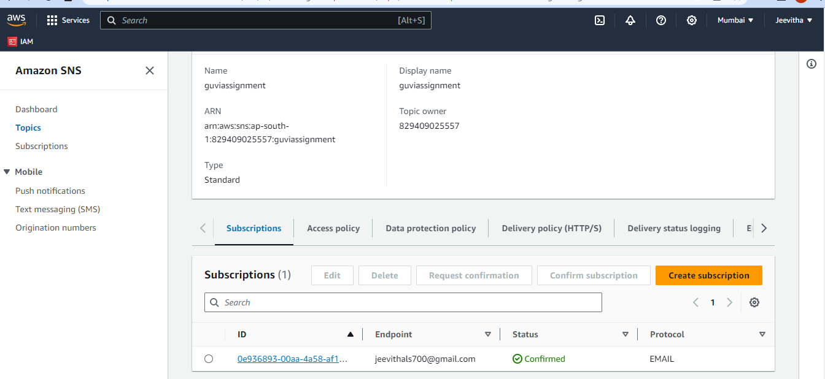

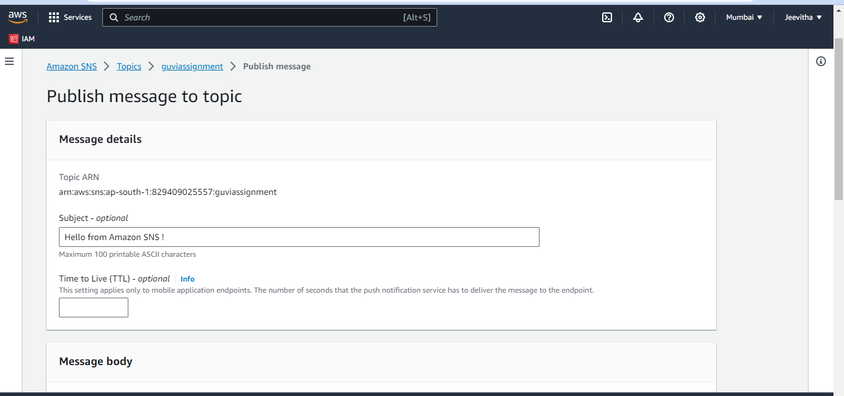

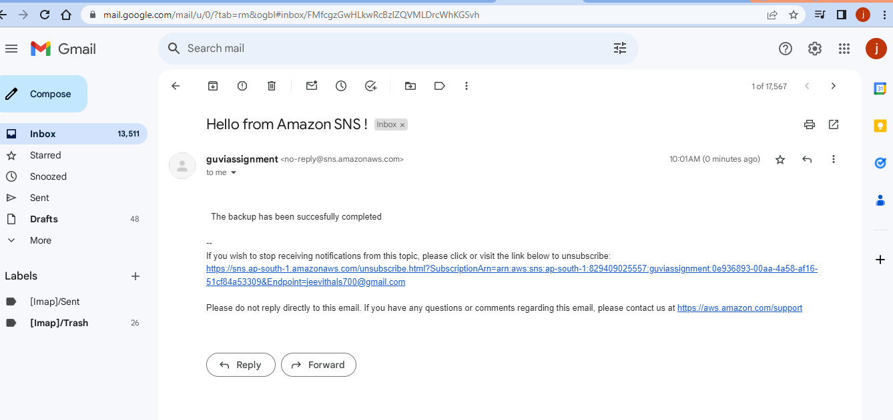

Sample Output 3: Creation of custom CloudWatch dashboards to visualize resource

performance and status, aiding in troubleshooting and analysis.

* 1.Access CloudWatch Dashboards:
  + In the CloudWatch console, navigate to "Dashboards."
* 2.Create a New Dashboard:
  + Click the "Create dashboard" button.
* 3.Add Widgets:
  + Add widgets to your dashboard to visualize the resource's performance and status. Choose the widgets that display relevant metrics for your resources (e.g., line charts, numerical values).
* 4.Customize Widgets:
  + Customize the widgets by selecting the metric, resource, and time range you want to display.
* 5.Organize Layout:
  + Organize the layout of your dashboard by dragging and dropping widgets to the desired positions.
* 6.Save the Dashboard:
  + Give your dashboard a meaningful name and save it.
* 7.Access the Dashboard:
  + You can now access and view your custom CloudWatch dashboard to monitor the status and performance of your AWS resources.

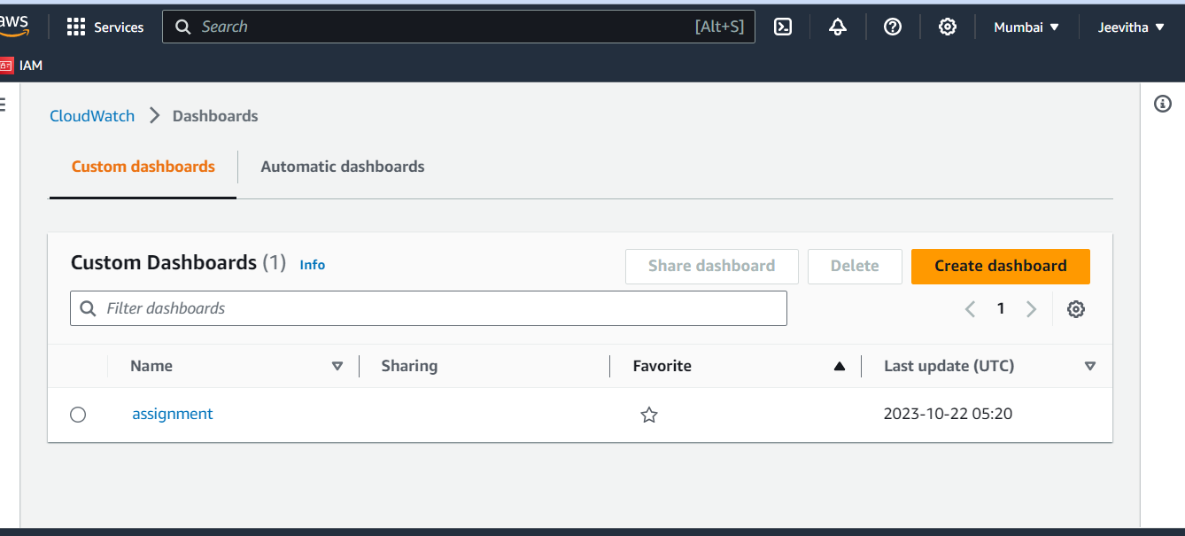

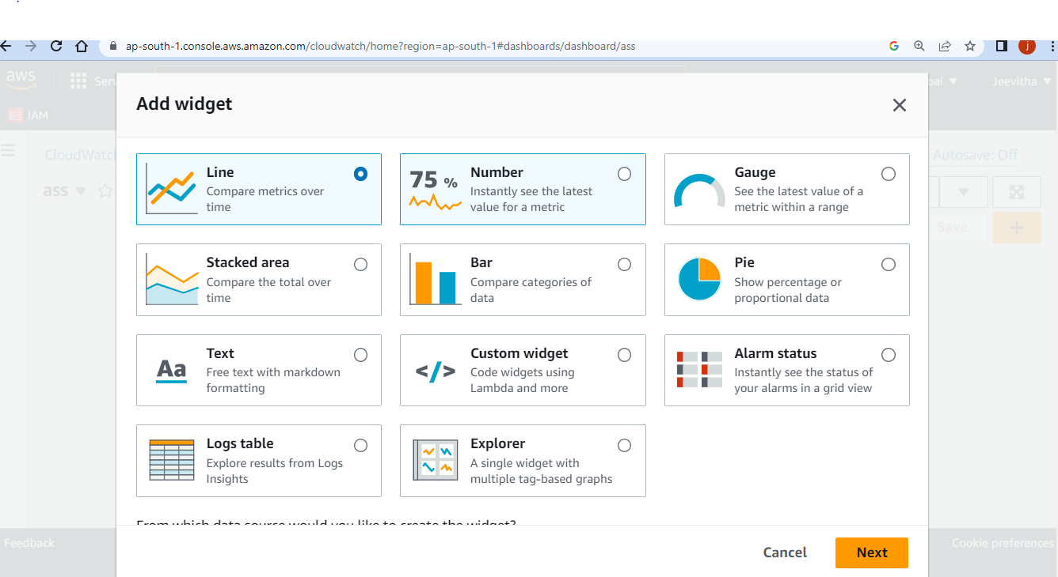



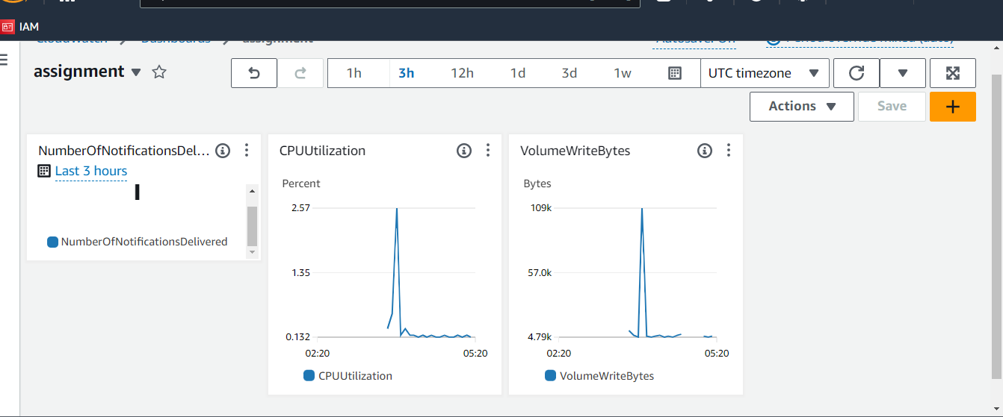ssss